Once Upon A Fall
By Filzah Athirah
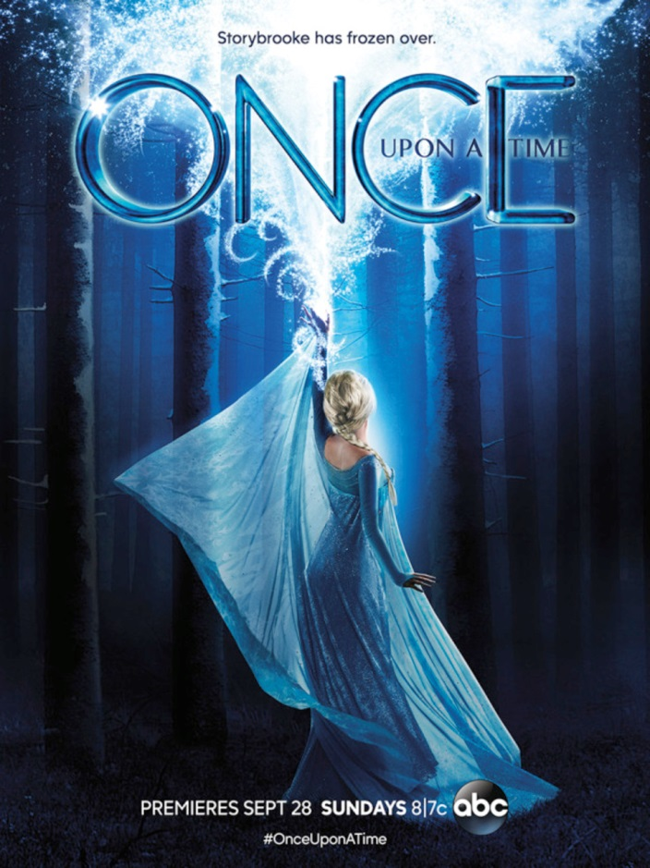
The dark, twisted ABC fantasy-drama that plays on our favourite childhood fairy tale characters wrapped up their fall finale December 14th 2014, leaving us with even more questions as we get through these 78 agonizing days until its return. In the first half of this season, Walt Disney Productions gave ABC the two thumbs up and brought the characters from the highly acclaimed animated feature Frozen, directed by Chris Buck and Jennifer Lee, to life in Once Upon A Time (OUAT).
There were two quests this season. One is to locate the author of the story book that controls the fate of all characters; the other is to reunite Elsa with her sister Anna, who never returned from her voyage to the Enchanted Forest (or 'Misthaven') in search of answers to their parents’ perish at sea. This season also focuses on Regina, played by the ever-so charismatic Latin actress Lana Parilla, and her pursuit of happiness despite being the Evil Queen.
The backstory revealed the history of Anna and Elsa’s mother and her two sisters, who were wiped off from the memory of the whole Kingdom of Arendelle. In true OUAT fashion, Anna and Ingrid, her aunt, crossed paths with Rumpelstiltskin, and the latter struck a deal with him. We now know to well that dealing with Rumple is a definite no-no!
The Frozen cast featured refreshing new faces in American TV such as Australian actress Georgina Haig, who had a fair share of screen time in the FOX sci-fi series Fringe, as Queen Elsa and Elizabeth Lail as Princess Anna. For Lail, this was her first TV breakthrough from having only done student film productions previously. She prefectly portrayed the naïve, leap-before-you-look Anna that we know and shows her promising talent in acting.
Props to the writers Edward Kitsis and Adam Horrowitz in successfully weaving in the Frozen characters (even Kristoff’s reindeer Sven!) into the already complicated situation in Storybrooke — present day Enchanted Forest -- where all the fairy tale characters are trapped since the first season.
I personally enjoyed the visit from Arendelle but I had wished they stuck to the OUAT mythology and gave the Frozen characters more interesting personas with dark pasts and mind-boggling connections to the two heavyweights Rumpelstiltskin (Robert Carlyle) and Regina, instead of sticking to the same characters they had in the animated movie.
That aside, it’s a tough season for 'Rump-Belle' fans! We may have thought that Belle’s beast had turned over a new leaf after his saga with the Wicked Witch of the West in Season 3, but his greed for power ultimately triumphs over his love for Belle.
Banished from Storybrooke, Rumpelstiltskin now heads to New York looking for the three Queens of Darkness who were revealed in the final episode to be Kristen Bauer van Straten as Maleficent, Merrin Dungey as Ursula and Victoria Smurfit as Cruella de Vil. Now what is 1920s London fashion doing in a land of fairy tales? Something tells me she might have had a past with Archie who owns the only Dalmatian in Storybrooke, Rongo.
What happens when Rumple meets the Queens of Darkness? Is he planning another curse? Will Regina ever have her happy ending? We can only wait for the answers as Once Upon A Time returns March 1st, on ABC at 8p.m.

