Marketing Communications Campaign Proposal
For Ministry of Manpower

TEAM MEMBERS

Praveena Ravin
Filzah Athirah Bte Suhaimi
Perle Ng
Olivia Marie Cheong Yee Yan
Syafiqah Idayu Binti Rosli

2014

Republic Polytechnic
1/1/2014

Table of Contents
EXECUTIVE SUMMARY 2
SECTION A 3
INTRODUCTION 3
SECTION B 4
SITUATION ANALYSIS 4
2.1 SWOT Analysis 4
SECTION C 5
Target Audience Analysis 5
Section D 5
Significant Findings 5
SECTION E 6
Proposed IMC Plan 6
5.1 Recommendations 6
5.2 Communication Objectives 6
SECTION F 6
Communication Strategy & Key Messages 6
SECTION G 7
Creative Strategy 7
5.1 Concept Plan 7
5.2 Key Highlights of IMC Plan 10
5.3 Promotional Tools 11
5.4 BUDGET 12
5.5 Timeline 14
EVALUATION 15
CONCLUSION 15
REFERENCES 16
BIBLIOGRAPHIC CITATION 17
APPENDICES 18
Appendix A 18
Appendix B 19
Appendix C 20
Appendix D 21
Appendix E 21
Appendix F 22
Appendix G 23
Appendix H 24
Appendix I 26
Appendix J 28
Appendix K 30

EXECUTIVE SUMMARY
This is a proposal by five students from the Diploma of Communication and Information Design in Republic Polytechnic.
The proposed Integrated Marketing Communication (IMC) plan is designed to help increase the awareness of key messages in FWs by 75% of 2013’s total number of roadshow recipients as well as generate awareness of the annual MOM roadshows by 75%.
The theme of the IMC plan focuses on The Rights Path. It reflects the core Ley Message(s) of FWs’ rights. As there is a need to not only inform the FWs of the Key Messages but to educate them as well, this theme represents a learning journey for the FWs as they learn of the Key Messages.
According to the analysis of the research, it would be more effective for the campaign to be extended to 5 months from the given 3 months. To ensure the communication tactics are used to its fullest potential, 5 months may more effectively imprint the Key Messages into the FWs’ minds.
The 5-month campaign would feature the use of several IMC tools to generate awareness of the Key Messages. There would be three main segments to the campaign: namely, the use of IMC tools to increase awareness of the Key Message ‘Employment Rights ad Responsibilities’; secondly, use of Public and Dormitory Roadshows; and thirdly, to direct the FWs to the public roadshows.
There would be activities such as contests, games, performances and movie screenings that would revolve around the theme The Rights Path.
The communication tools employed for the IMC plan would include radio advertisements, radio shows, posters, personal selling (Ming’s fanclub), advertising on shuttle buses, Dormitory and Public Roadshows.
There would be an evaluation conducted after the conclusion of the campaign to gather feedback and measure the effectiveness of the IMC tools to increase awareness of the Key Messages. The measuring tools include a questionnaire and number call-ins on the radio show.

SECTION A

INTRODUCTION
The Ministry of Manpower (MOM) is responsible for directing the formulation and implementation of policies related to manpower in Singapore.

Vision: A Great Workforce. A Great Workplace.
Mission: To develop a productive workforce and progressive workplaces, for Singaporeans to have better jobs and a secure retirement.

MOM’s department, Foreign Manpower Management Division (FMMD), is responsible for the management of the foreign workers in Singapore. FMMD aims to help foreign workers (FWs) to better understand their employment rights and responsibilities through different information platforms. It also protects the well-being of said party such as enforcing the minimum acceptable accommodation standards which foreign workers can live in, and ensuring employers pay workers’ salaries on time.

FMMD works closely with other government agencies and the Migrant Workers’ Centre (MWC) to help foreign workers when they are faced with difficulties.

Some of the current initiatives include public roadshows and activities such as game booths, stage performances and the appearance of Mascot ‘Ming’. Standees and pop-up stands are placed at event venue during duration of the roadshows.

This proposal aims to create a more strategic framework to ensure more FWs are aware of the campaign’s key messages.

SECTION B

SITUATION ANALYSIS
The team conducted several studies between January 10 to February 7 to gather more information about previous MOM dormitory and public roadshows and its target audience. Studies include interviews with the FWs and online research for relevant data.

2.1 SWOT Analysis
The table below summarises the macro- and micro-environment that MOM operates in. (Refer to Appendix A for the full PESTLE Analysis.)

STRENGTHS:  - Strong partnership with WSH Council, NEA, SPF May help with publicity  - MOM holds credible reputation  - MOM has whole database of FWs  - MOM understands FWs | WEAKNESSES:  - Only reached out to limited number of FWs  - Selective SMS blast  - Only reached out to 1000-2000 FWs in 2013  - Only 2 annual Dormitory Roadshows  - Only 1 annual Public Roadshows
OPPORTUNITIES:  - FWs in possession of mobile phones  - FWs live in dormitories congregated together  - Private buses ferry foreign workers to Little India & to work  - ‘Working in Singapore’ newsletters are distributed at purpose-built FW dormitories  - Some FWs use social media (e.g. Facebook)  - 8 out of 10 FWs own a smartphone  - Singapore is multi-cultural  - Higher demand for housing  - FWs listen to the radio often | THREATS:  - Language barriers  - FWs tend to not ask questions when in uncertainty  - FWs may not read ads in magazines  - May have errands to run during roadshow  - Alcohol ban  - Singaporeans has low acceptance of FWs  - Singaporeans may hold belief that FWs would take their jobs  - Threats of haze  - Summer season during campaign  - Singapore may suffer economy crisis & lack of sufficient workforce with absence of FWs

SECTION C

Target Audience Analysis
The profile of the target audience is as follows:
Profile of Target Audience
Geographic Segmentation | Region | Congregated together across the 40 FW dormitories in Singapore (refer to Appendix B for full list)
Demographic Segmentation | Age | 18 – 50 year olds
 | Gender | Male
 | Nationality | Bangladesh, China, India
 | Sector | Construction; Marine; Manufacturing
 | Salary | $700/month
 | Education | Low education; low/semi-skilled
Psychographic Segmentation | Personality | - Attracted to simple activities  - Indirect and so are subtle when expressing less favourable feelings  - Hopes to integrated into Singapore society  - Miss aspects of home country
 | Lifestyle | - Avoids town areas as they feel unwelcome in Singapore; hangs out at Geylang, Little India, Chinatown  - Highly influenced by peers  - Family has top priority  - Enjoys free movie screens (pertaining to Bangladeshis & Indians)  - Likes to relax during resting hours
Usage Pattern | Means of Communication | - Mobile Phones  - Newspapers  - Whatsapp  - Facebook

Section D

Significant Findings
- FWs are technologically inclined
The team had attended a roadshow at the FWs’ Tuas dormitory on January 29 to see first-hand the current MOM’s dormitory roadshow and to interview several FWs on-site. From the interviews (refer to Appendix B), the team has gathered 8 out of 10 FWs at the dormitory own a smartphone. Also, they use their phones to listen to the radio for Hindi songs from 5pm to 8.30pm on mostly X96.3FM and Oli 96.8FM. Chinese workers are more inclined to listen to Love 97.2FM and rely on text messages for information.

- Previous Public Roadshows reached out to 1000 – 2000 FWs
According to the research gathered, previous Public Roadshows managed to gather an estimated 1000 – 2000 FWs. The IMC tools used did not manage to reach out to many FWs and so were not effective in generating awareness of the Key Messages to the Target Audience.
- FWs are congregated together
According the conducted research, the FWs live together in dormitories. This is an opportunity as the location could serve as a medium through which the Key Messages could be communicated to the FWs.

- FWs hopes to be integrated into Singapore society
From the interview conducted at the FW Tuas Dormitory, findings have shown that FWs hope for more positive interaction with Singapore locals. They desire to be more assimilated in Singapore society. However, they avoid town areas such as Orchard as they feel unwelcome as well.

SECTION E

Proposed IMC Plan

5.1 Recommendations
From the findings, the team recommends an extension from the given timeframe of 3 months to 5 months. As the Usage Pattern of the FWs are limited, a longer campaign duration may more effectively imprint the Key Messages into the FW’s minds. Hype could be built up in the FWs to not only attend the roadshow, but to be more aware of the Key Messages as well.
The 5 months would be used to maximise usage of marketing communications resources to its fullest potential as well as secure and maximise participation in the FWs.

5.2 Communication Objectives
- Increase number of FWs ‘ participation in roadshows by 75% (total equals to 5000 FWs) by end of August 2014
- Raise awareness of MOM’s Key Messages to 15000 FWs by end of August 2014

SECTION F

Communication Strategy & Key Messages
Together with the client brief, there will be 4 Key Messages for the Campaign Proposal. They are:
- Compliance with law – FWs must comply with Singapore’s laws
- Awareness of rights and responsibilities – Ensure awareness of employment rights and responsibilities while working in Singapore
- Awareness of illegal offences and consequences – Knowledge about various employment offences and the penalties for it
- MOM’s actions against offenders – MOM will take action against offenders who commit illegal offences

The team’s proposed campaign would focus on the theme The Rights Path. The word Rights relates and reflects the core Key Message(s) of the FWs’ rights; the word Path represents the element of being made aware of the Key Messages a journey of which the FWs are to go through.
The reason behind this proposed theme is the needs to not only inform the FWs of the Key Messages, but to educate them as well. Learning of any kind is a journey in itself, and is riddled with uncertainty and the need for answers. The Rights Path represents a campaign where those involved are dedicated to educating the FWs about their rights, and thus aligns appropriately to the given Key Messages.
This theme would be reflected in the IMC tools.

SECTION G

Creative Strategy

5.1 Concept Plan
The campaign would feature three main parts; namely:
- Public Roadshows with usage of IMC tools to direct FWs to the roadshows; and
- Dormitory Roadshows; and
- Generate awareness of Key Messages through IMC tools
(Refer to Appendix C for full details)

5.1.1 Public Roadshows
The Public Roadshows would be named The Rights Path: Foreign Workers’ Funfair to illustrate an integration of joy into activities that aim to increase awareness of the Key Messages. It would be held at 10 Jurong East Street 12, opposite Jurong East MRT from 9am – 6pm on 16 – 17 and 23 – 24 August 2014. This location is near to most of the FW dormitories in Singapore. Unlike Geylang, Little India or Chinatown, this location is popular among FWs of all ethnicities and across the various sectors.
There will be games, performances, a lucky draw, picnics and a scenario exhibition panel. The Rights Path: Foreign Workers’ Funfair would contain 4 different areas (refer to Appendix D); each focuses on a part of the Key Message. For example, at the first area, the activities aim to generate awareness of the importance of Compliance with the Law.
- Area A/ Activity 1: Scenario Exhibition Panels
The first area would contain a Registration Booth and a Scenario Exhibition Panel. The Registration Booth would collect the personal data of participants while giving out goodie bags and a Stamp card. At the conclusion of each area, the FWs would receive a stamp. Participants with completed Stamp Cards would be eligible for the lucky draw at the end of the Roadshow.
The Scenario Exhibition Panels would focus on the Key Message: Compliance with the Law. There will be panels that would feature various scenarios (refer to Appendix E) that Ming, the Mascot is stuck in. FWs would be given play cards. Beneath the pictures on the cards would contain the various options that FWs could take. The flip side would display the consequences of each action. Conclusion of this activity would result in 1 stamp.
- Area B/ Activity 2: Hot Seat Booth & Water Gun Challenge
The second area would focus on the Key Message: Awareness of Employment Rights and Responsibilities. The activity here would feature a Hot Seat, of which a ball pit would be placed underneath it. A booth manager would be present to pick out a few persons to sit on the Hot Seat. 5 questions (refer to Appendix F) related to the Key Message would be posed to the crowd. In the case whereby 2 questions are answered wrongly, the Hot Seat’s occupant would be dropped into the ball pit. There would be a stage beside the Hot Seat whereby FWs who attempt to answer the questions are invited to the stage to answer.
Another activity is the Water Gun Challenge. There would be 5 Water Gun Challenge booths to cater to the number of FWs present. Participants would be given ‘True/False’ questions related to the Key Message by the booth manager. The participants would receive a water gun and would be required to shoot 4 cards with the ‘Truth’. If they were to shoot a ‘False’ card twice, the participant would have to step back and wait another turn.
Conclusion of any one of this activity would result in 1 stamp.*
Note: Participants may obtain a maximum of 1 point from this Area.
- Area C/ Activity 3: Skits & Corporate Commercials
The fourth area would focus on the Key Message: MOM’s Actions against Offenders. It would feature actors playing various scenarios based on the Key Message. There would also be corporate commercials displayed during this segment.
- Area D/ Activity 5: Picnic and Lucky Draw
The fifth activity would feature a picnic and lucky draw. A group of volunteers from Ming’s Fan Club (see Section: Key Highlights of IMC Plan/Personal Selling) would sit with the FWs during the picnic and discuss personally the Key Messages with the FWs. This plays on the FWs’ desire to be integrated with and build stronger relationships with the locals. This would also act as further education with the FWs whereby they are able to ask questions in uncertainty. A survey form would be given to them as well to evaluate the effectiveness of the campaign.
Participants with the completed set of stamps would be eligible for the lucky draw. Prizes include Samsung Galaxy S4, an iPod and Apple Earpods with Remote & Mic.

5.1.2 Dormitory Roadshows
Dormitory Roadshows would be named Coming Home, which would feature a movie screening of Mr Bean movies, a popular family show. The basis behind Coming Home is a method to instill into the FWs that the dormitories hope to provide them with a sense of belonging. It is a sub-section of The Rights Path. This plays upon the dormitories the place in which the FWs return to after work.
It would be held on Wednesdays of June and July (11 & 25 June; and 9 & 23 July) when FWs are only halfway through the week before the weekends. This way, the roadshow may act as the interval through which the FWs are able to relax doing something fun and out of routine. The locations are the Tuas Dromitory, Mandai Dormitory and Toh Guan Dormitory. They are chosen as the three FWs dormitories are the largest of the 40 FWs dormitories in Singapore. This would therefore ensure a higher participation and exposure levels of the Key Messages.
As the FWs consist of 3 different ethnicities, Mr Bean is appropriate as it requires little to no subtitles and is an entertaining comedy to watch. It would be played for an hour from 7.30 to 8.30 pm. This is to imprint the Key Messages in the FWs by playing them consistently during these roadshows.
The commercial breaks during the movie screening would showcase MOM’s corporate videos (refer to Appendix G) on Key Messages.
An MOM representative would open Coming Home as an opening to the roadshow. Booths would be set up at the back of the event where FWs could collect goodies such as Waterbottles and T-shirts. Each goodie would contain any of the Key Messages. For example, the T-shirts would have a Key Message engraved on its front.

5.1.3 Usage of IMC Tools to promote Key Messages
(Refer to Appendix C for overview of IMC plan)

Database Marketing
An SMS blast should be used as a communication tool to reach out to the FWs. From the data gathered, the majority of FWs are using mobile phones. The SMS blast would be sent out twice in June and July each (13 & 27 June; and 11 & 25 July) and aims to reach a cumulative of 10,000 people in a month. It would be targeted specifically to FWs who are newer to Singapore; for example, FWs who has been in Singapore for less than 2 years. They would require more knowledge on the Key Messages as they are more likely to be unfamiliar with them as opposed to those who have been in Singapore for a longer period of time.
The SMS Blast would contain information on the Key Message: Employment Rights and Responsibilities (refer to Appendix H). This would be named Ming’s Tips of the Day.

Advertising: Posters
The Foreign Workers prefer to receive information through posters in their dormitories. This may ensure high ‘exposure’ of posters to the target audience as they would have to walk by them. This aims to reach 10,000 people in a month and should be put up by 7th of April. (Refer to Appendix I for mock-up of posters)
The Posters would convey 7 Key Messages. These Key Messages are a sub-category of Employment Rights and Responsibilities. Examples are as follows:
- One Work Pass, One Job
- Don’t exceed 8 hours of work

With an average of 50 posters per dormitory, there should an estimated 2000 posters in total. The posters (not categorised by Key Message) would be placed along each dormitory to maximise exposure to target audience.

Advertising: Radio
There would be two segments to Radio advertising; namely LIVE Broadcast: Ming’s Competition and Ming’s Talk Show.
- LIVE Broadcast: Ming’s Competition
One key highlight of the IMC plan is to make use of a LIVE Broadcast with Radio channels Oli 96.8FM and LOVE 97.2FM. This is a talk show whereby FWs are invited to call in and answer questions that could be related to any of the 4 Key messages. There would be an hour per segment every 8 pm to 8.30 pm and held for 12 weeks (19 May to 8 August) to allow increased interaction with more FWs and to further imprint the importance of awareness of the Key messages.
A few example questions are as follows:
- If someone offers you a job as a painter, would you take it?
- Are you allowed to work beyond 8 hours a day?

For every participant who have correctly answered the questions, their name would be included in a lucky draw. One name would be drawn every week. Altogether, 12 participants stand to win All-in-1 Passes for the DUCK & HiPPO tour for correctly answered questions. As FWs who have yet to experience Singapore, these prizes offer them the opportunity to do so and so understand and feel more strongly for the country.

They are to redeem their prizes any one of The Rights Path: Foreign Workers’ Funfair roadshows.

5.2 Key Highlights of IMC Plan

- Ming’s Talk Show
There could be a segment of which there is a Talk Show on radio channels Oli 96.8FM and LOVE 97.2FM. It would be conducted from 6.30pm to 7.30pm, a popular timing at which the FWs listen to the radios. It would be played on a frequency of 5 times a week in one-hour segments.
FWs are invited to call-in to the radio Talk Show. The Talk Show consists of a discussion between the DJs and the FWs with the main goal to generate awareness of the Key Messages. A topic of discussion may be chosen per session. For instance, ‘One Work Pass, One Job’. The content of the discussion may be aligned to this topic, whereby FWs and the DJ may discuss the importance of said law, or even the difficulties that accompany abovesaid law.
This Talk Show aims to increase interaction and involvement with FWs as they are educated about the Key Messages.
- Personal Selling: Ming’s Fanclub
Many of the Foreign Workers spend their weekends at popular hang-out locations such as Geylang and Little India to relax on open fields. This is an opportunity for MOM to reach out to them. A volunteer team comprising of 40 volunteers to educate the FWs of the Key Messages and also inform them of the upcoming Public Roadshow could be set up. This team could be known as Ming’s Fanclub to give the impression of a group of staff dedicated to achieving the goals of the Key Messages.
Ming’s Fanclub are to venture into the FWs’ popular hangouts (Geylang, Little India, Chinatown etc.) and approach them to personally talk to them about the Key Messages. They are to engage the FWs with relevant information as well as encourage the FWs to ask questions. This would facilitate a stronger faith in FWs of MOM and allow the target audience the opportunity seek answers upfront.
Category | Description
Volunteers | - Should comprise of Grassroot volunteers. Research has shown FWs feel unwelcome in Singapore society and hope to integrate with the locals.  This may break down some of the barriers between the two parties. Furthermore, it is an opportunity for locals to have a deeper understanding of the FWs through a more face-to-face manner.
Location | - The location would be centralised around Geylang, Little India and Chinatown. Ming’s Fanclub would be able to reach out to a higher number of FWs easily as FWs are heavily congregated at these areas.
Attire | - The volunteers are to don the same attire as Ming, the Mascot. Also, at least 2 – 3 of the Mascot is to wander around Geylang, with the volunteers doing the same as well.  While the volunteers would be more proactive in seeking out the FWs, the reason behind Ming’s presence and the chosen attire is to appeal to passers-by’ curiousity.  The audience would be aware that there is an event going on and so may be incited to find out what.
Goodie Bags | - Notebooks are to be given at the conclusion of each session with a group of FWs. The first 4 pages would include detailed information on each Key Message. The rest of the pages would be blank, save for a line pertaining to any Key Message at the bottom of each page.  E.g.:  - One Work Pass, One Job  - It is illegal for an employer to demand payment from you

- Mascot
Many of the IMC tools are named according to Ming, the Mascot. A few examples are LIVE Broadcast: Ming’s Competition, Ming’s Fanclub, Ming’s Tips of the Day. They are named so as Ming is a familiar face to FWs and represents the Work Rights of FWs.
The ambassador is hence representative of the aims of this campaign.

5.3 Promotional Tools
- Advertising: Posters on Shuttle Buses- Most Foreign Workers take the Shuttle Bus provided by their employer to take them to and from work every day. Advertisements could be put up inside each Shuttle Bus as it could be ‘communicated’ to the target audience easily and frequently. These advertisements comprise of posters and would be placed behind the backseats in the bus. (Refer to Appendix J for mock-up of poster.) This aims to reach 10,000 FWs in a month.
- Database Marketing: SMS Blast – To complement Usage of IMC Tools to promote Key Messages: Database Marketing, there may be a small section at the end of the text message promoting the Public Roadshows to the FWs. This aims to make use of all and any available resources to ensure maximum awareness of the Public Roadshows to the FWs.
- Personal Selling: Ming’s Fanclub – To complement Key Highlights of IMC Plan, the volunteer team are to inform and remind the FWs of the upcoming Public Roadshow. Also, they are to give out the notebook, which would contain a page that would refer the FWs to the roadshow. This is to ensure that more FWs are aware of the Public Roadshows.
- LIVE Broadcast: Ming’s Competition – To complement Key Highlights of IMC Plan, at the beginning and end of each Radio Talk show session, the DJs on show are to inform and remind the target audience of the upcoming roadshow with details such as the date, time, venue and directions as well.

5.4 BUDGET
No. | Item | Description | Cost (S$) | Quantity | Total (S$)
Advertisements
1 | Posters | A3 size | 2.14 | 2000 | 4280
2 | Flyers | 216 mm by 139 mm | 0.74 | 2500 | 1840
3 | Radio Advertising – Oli 96.8FM | Talk Show | - | 1 hour*40 | 2830
4 | Radio Advertising – Oli 96.8FM | Competition – ‘LIVE’ Broadcast | - | 30 min*40 | 1415
5 | Radio Advertising – LOVE 97.2FM | Talk Show | - | 1 hour*40 | 8500
6 | Radio Advertising – LOVE 97.2FM | Competition – ‘LIVE’ Broadcast | - | 30 min*40 | 4250
7 | SMS Blast | FortDigital SMS Blast | 0.049 | 5000*5 | 1225
8 | Shuttle Bus Transport Ads | - | 400 | 20 | 8000
Goodie Bags
1 | Towel | Inscribed with Key Messages | 1.90 | 5000 | 9500
2 | Waterbottle | Inscribed with Key Messages | 2.00 | 5000 | 10000
3 | Notebook | Inscribed with Key Messages | 0.46 | 5000 | 2300
4 | T-shirts | Inscribed with Key Messages | 7.00 | 300 | 2100
5 | Foldable Drawstring Bag | Inscribed with Key Messages | 2.30 | 5000 | 11500
Contest Prizes
1 | Hippo Bus Trip | Contest Prizes | 12 | 79 | 940
Lucky Draw
1 | Samsung Galaxy S4 | Lucky Draw | 670 | 1 | 670
2 | iPod | Lucky Draw | 200 | 1 | 200
3 | Apple Earpods with Remote & Mic | Lucky Draw | 42 | 2 | 84
Grand Total |  |  |  |  | 69634
(Rounded Off) |  |  |  |  | 70000

5.5 Timeline
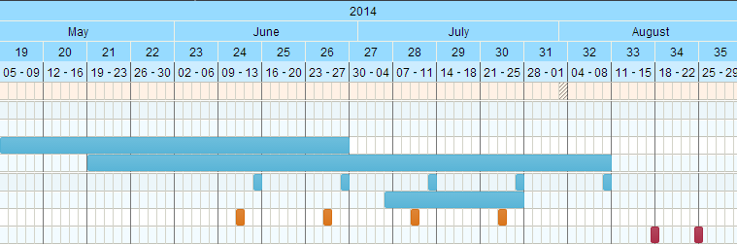
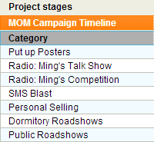

EVALUATION
The following are the methods of evaluating the success of each IMC tool.
No. | IMC Tool | Method of Evaluation | Measurement
1 | Radio | Number of Call-ins during LIVE Broadcasting: Ming’s Competition | 3 call-ins out of 5 per segment
2 | Personal Selling | Survey (Refer to Appendix K) | -
3 | Dormitory Roadshow: Coming Home | Survey (Refer to Appendix K) | -
4 | Main Roadshow: Foreign Workers’ Funfair | Survey (Refer to Appendix K) | -

The evaluation would be done by counting the number of referrals the FWs used to be informed of the Key Messages, as well as the Public Roadshows. The surveys would be conducted to find out the perception of the target audience of the Public Roadshows and use of the IMC tools.

CONCLUSION
Through this IMC Plan, MOM would be able to meet their goal to generate awareness of the Key Messages through the roadshows and other IMC tools. Furthermore, they would be able to better integrate the FWs into Singapore society.

REFERENCES
- http://news.asiaone.com/News/Latest+News/Singapore/Story/A1Story20121209-388579.html
- http://www.channelnewsasia.com/news/singapore/more-can-be-done-to/959986.html
- http://ap4.fas.nus.edu.sg/fass/socect/Thompson%202009%20GN.pdf
- http://news.asiaone.com/news/singapore/little-india-riot-foreign-workers-gather-relax-food-and-alcohol
- http://articles.stclassifieds.sg/health-beauty-and-fashion/more-recreation-centres-for-foreign-workers-better-than-weekdays-off-bosses/a/151118?utm_source=STJobs&utm_medium=Footer&utm_content=Articles&utm_campaign=Jobs
- http://www.straitstimes.com/the-big-story/little-india-riot/story/give-more-thought-providing-social-activities-workers-20131211
- http://news.asiaone.com/news/singapore/foreign-workers-get-voice-their-own
- http://communicate.sg/news/201302/foreign-workers-selective-cuts-rise-in-levies-unveiled.html
- http://www.straitstimes.com/breaking-news/singapore/story/migrant-workers-spend-rest-days-volunteering-20140106
- http://www.straitstimes.com/premium/forum-letters/story/help-available-migrant-workers-distress-20130926
- http://www.vistaprint.sg/flyers.aspx?mk=flyers+%2bcost&ad=b&crtv=31352439914&psite=mkwid%7cpeUUs7zu&device=c&gclid=CN2s9eLMtrwCFVFU4godrQQA0Q&GP=2%2f5%2f2014+10%3a52%3a18+PM&GPS=3096336399&GNF=0
- http://www.sla.gov.sg/htm/ser/ser0210.htm
- http://www.smrtmedia.com.sg/ProductsRates/Bus.aspx
- http://www.onemap.sg/index.html
- http://www.klassic.com.sg/corporateproducts_details.asp?cat=151&parent=97&id=1236
- http://www.channelnewsasia.com/news/singapore/singapore-s-economy-grows/940498.html
- http://sg.news.yahoo.com/80-per-cent-say-singaporeans-are-becoming-anti-foreigner--y--poll.html
- http://sg.news.yahoo.com/are-singaporeans-becoming-racist-.html
- http://sg.news.yahoo.com/blogs/property-blog/demand-residential-property-singapore-sustainable-6-million-080619235.html
- http://www.oxlearn.com/arg_Marketing-Resources-PESTLE---Macro-Environmental-Analysis_11_31
- https://www11.mediacorp.sg/promotions/download/radio-rate-card
- http://www.ducktours.com.sg/sp.php

BIBLIOGRAPHIC CITATION
- http://sg.news.yahoo.com/foreign-workers-singapore-bear-brunt-021924424.html
- http://www.nptd.gov.sg/content/NPTD/news/_jcr_content/par_content/download_84/file.res/OP-Projection%20of%20foreign%20manpower%20demand%20for%20healthcare%20sector%20construction%20workers%20and%20foreign%20domestic%20workers.pdf
- http://news.asiaone.com/news/singapore/web-savvy-foreign-workers?page=0%2C3
- http://www.straitstimes.com/premium/forum-letters/story/understand-perspectives-foreign-workers-20131212
- http://news.asiaone.com/news/singapore/where-other-foreigners-hang-out
- http://www.straitstimes.com/the-big-story/little-india-riot/story/new-traffic-arrangements-little-india-area-sundays-lta-2013122

APPENDICES

Appendix A
PESTLE Analysis
P-olitical | - Roadshows convey policies & regulations the government is trying to promote  - Policies that protect the FWs in place are important as 40% of Singapore’s total workforce are FWs  - Singapore would suffer economy crisis and lack of sufficient workforce with absence of FWs
E-conomic | - Economy grew 4.4% on year-on-year basis in fourth quarter of 2013  - Unemployment rate of 1.8 person as country’s red hot construction sector has been attracting overseas workers  - Growing number of wealthy citizens hiring FWDs  - Manufacturing sector expanded by 3.5% in Q4, compared to 5.3% in Q3  - Growth of construction sector slowed to 4.7% due mainly to slowdown in private sector activities  - Higher demand for housing  - Services industry grew 5.5%
S-ocio Cultural | Singapore  - Multi-cultural  FWs  - Work-permit workers  - Low-skilled workers  - Low education; may not understand messages  - Language: Bangladesh; Mandarin; Indian  - Age: 18-50 year olds  - Workers tend to not ask questions in uncertainty  Singaporeans  - High education  - Main Language: English  - 80% polled under ‘Are Singaporeans becoming anti-foreigner’ chose ‘Yes’  - Slowly becoming more acceptable of foreign workers  - May have the belief that foreign workers would take their jobs
T-echnology | - FWs are in possession of mobile phones (mostly Samsung)  - Some FWs use social media (e.g. Facebook)  - 8 out of 10 FWs own a smartphone
L-egal | - Alcohol ban in Little India
E-nvironment | - Summer season during campaign  - Threats of haze

Appendix B
List of Interview Questions for FWs
- Have you ever attended an MOM public roadshow?
- If yes, how did you know of it?
- What would you expect from a roadshow?
- Do you know the purpose of the roadshow?
- What type of activities would you want to participate in?
- Are you aware of Singapore’s Workforce policies?

Appendix C
Overview of IMC Tools to be used
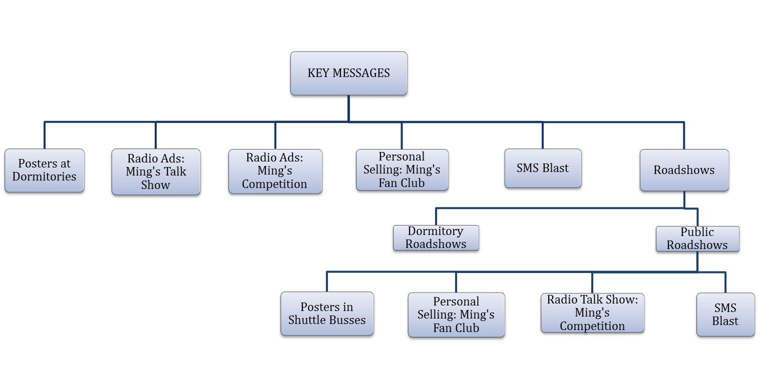

Appendix D
Floorplan of Public Roadshow
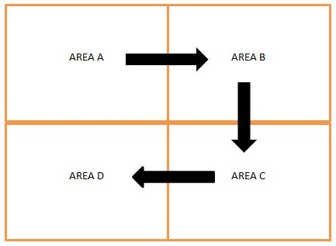

Appendix E
List of scenario examples for Public Roadshow’s Area A

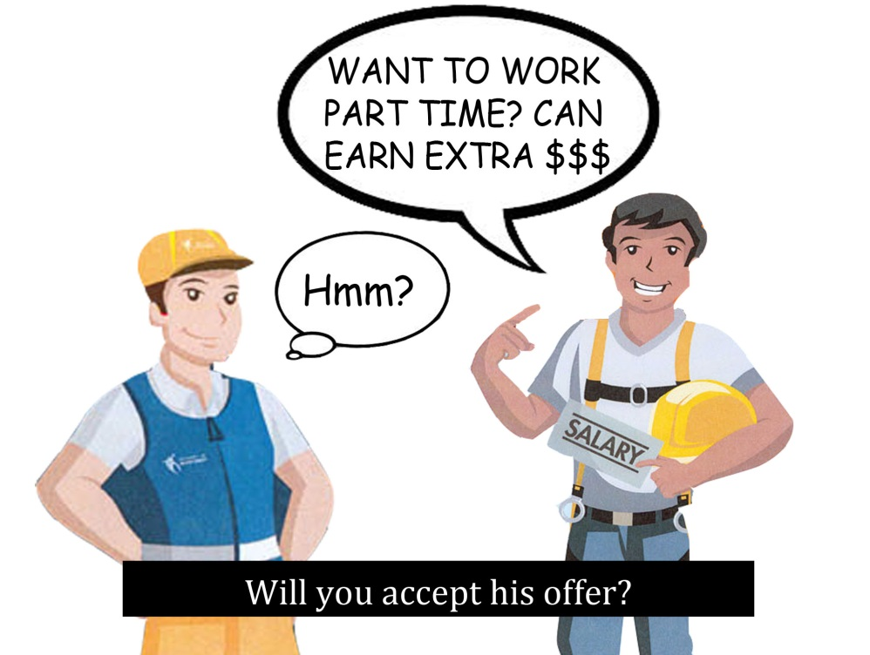

Appendix F
List of example questions for Public Roadshow’s Area B
- Can you have 2 jobs per work permit?
- Do you need to pay for your own medical fees?
- Can your boss ask you for extra money other than the agency fee?
- You should receive your salary at least once a month. (T/F)
- You should receive your salary within 7 days after the date your boss said he would pay you. (T/F)
- You should not work more than 8 hours a day unless you are on shift (T/F)
- You can claim 1.5 times your hourly pay if you work overtime (T/F)
- It is illegal for your boss to not let you rest one day per week
- You are still paid on public holidays (T/F)
- If your boss asks you to work on your rest day or a public holiday, you can get 2 days of your basic salary (T/F)
- If you have worked for 8 years for your same boss, you can get 14 days paid annual leave (T/F)
- Do you need to have an MC to take sick leave?
- Can you tell your boss that you are taking sick leave on the day itself?
- You have 15 days sick leave and 60 days hospitalization leave (T/F)
- Can you take sick leave if you have worked for your boss for 2 months?

Appendix G
Storyboard mock-up for corporate commercial during Dormitory Roadshows
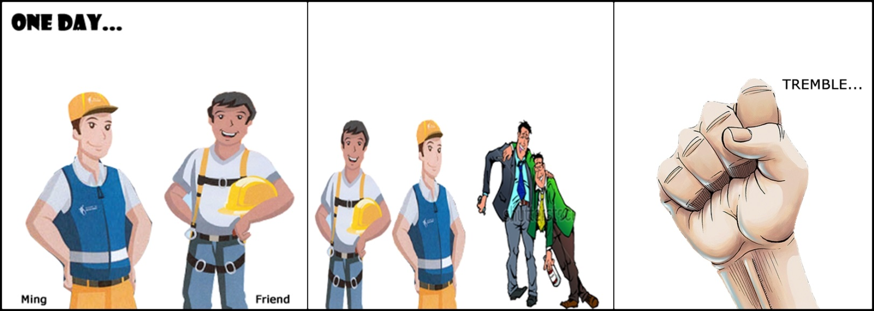

Appendix H
SMS Blast
Ming’s Tips of the Day: Did you know? You can only have one job per work pass. If you work without a work pass, you will be fined S$20,000 and/or jailed up to 2 years. For enquiries, contact Ministry of Manpower @ 6438 5122
MOM | The Rights Path

Ming’s Tips of the Day: Did you know? You can only have one job per work pass. If you work without a work pass, you will be fined S$20,000 and/or jailed up to 2 years. For enquiries, contact Ministry of Manpower @ 6438 5122
MOM | The Rights Path
Ming’s Tips of the Day: You should be paid within 7 days of the time your boss said he would pay you. For enquiries, contact Ministry of Manpower @ 6438 5122
MOM | The Rights Path

Ming’s Tips of the Day: Your workplace should be clean and comfortable. Obey rules and keep the place in order. For enquiries, contact Ministry of Manpower @ 6438 5122
MOM | The Rights Path
Ming’s Tips of the Day: Check if the company which gave you a job is licensed under MOM as it is illegal if they are not. You can be fined up to $5000. For enquiries, contact Ministry of Manpower @ 6438 5122
MOM | The Rights Path

Ming’s Tips of the Day: Your employer cannot make you pay for money that is more than 2 months of your salary. If the company fires you within 6 months, you can get half of the money you paid to them. For enquiries, contact Ministry of Manpower @ 6438 5122
MOM | The Rights Path
Ming’s Tips of the Day: Your boss should pay for all the costs of hiring you. If they say that you need to pay for anything else, tell them that it is illegal. For enquiries, contact Ministry of Manpower @ 6438 5122
MOM | The Rights Path

Appendix I

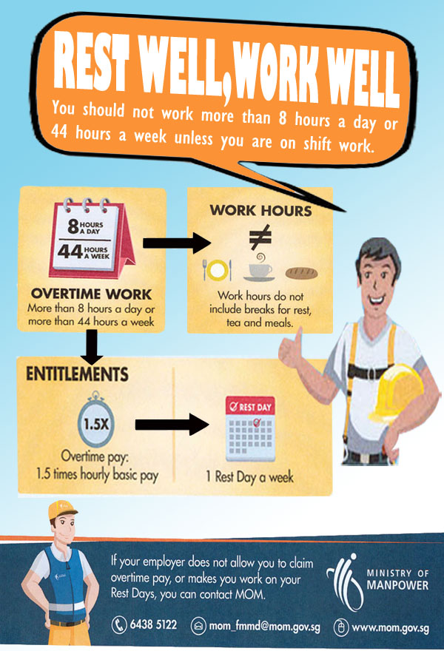
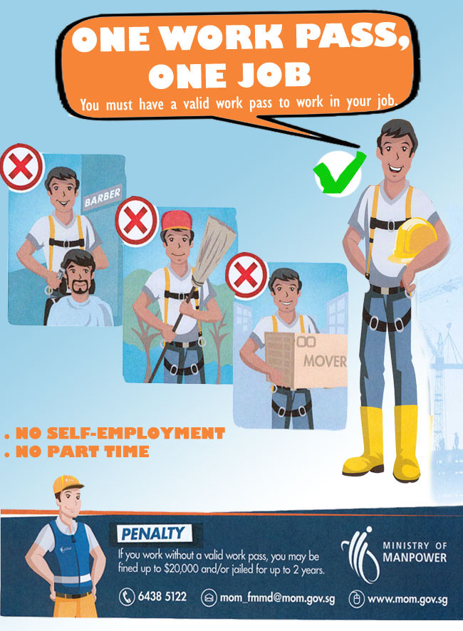

Appendix J
Mock up Poster in Shuttle Bus
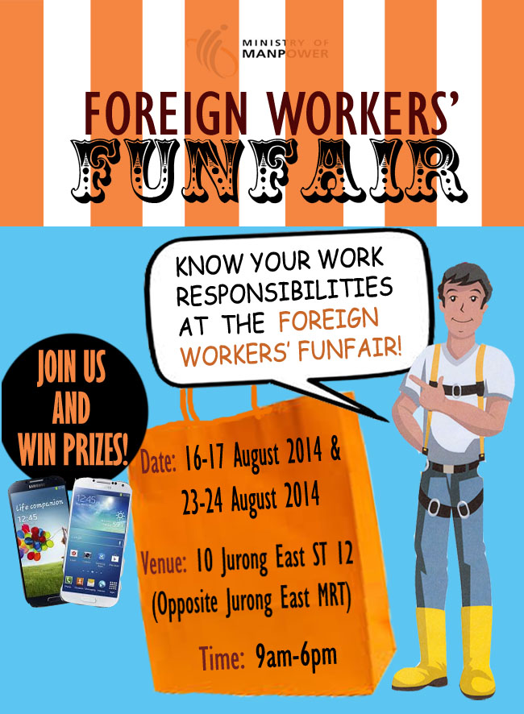
Layout of Posters in Shuttle Bus

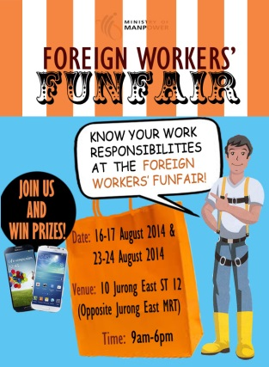

Appendix K
List of survey questions for evaluation purposes
Please take time to complete this survey about the roadshow you have just attended. Your feedback is very much appreciated.
- Select your Nationality:
- Chinese
- Bangladeshi
- Indian
- Others: ______________________
- Select your age:
- 18-25 years old
- 26-39 years old
- 40-55 years old
- 56 years old and above
- Which sector are you working in?
- Construction
- Marine
- Manufacturing
- Others: ______________________
- How did you know about this roadshow?
- Radio
- Posters
- Flyers
- Friends (Word of Mouth)
- Others: _______________________
- What did you learn? (You may tick more than one)
- One Work Pass, One Job
- My Employment, My Employer Pays
- No Licence, Walk Away
- Agency Fee: Know The Limits
- Rest Well, Work Well
- Salary on Time, Every time
- Good Housekeeping, Better Living
- Was the roadshow fun?
- Agree
- Neutral
- Disagree

